ANA-050 Functional Specification
Simpsons Beverages: Automate start, stop reporting on operation

Document Properties
Authors | Eshan Fernando | Infor M3 Consultant

Approvers
Approvers | Bevon Raj | Senior Consultant | Date: 12/05/2026

Change Control | Eshan Fernando | Creation | Date: 12/05/2026
Change Control |  |  | Date

Contents
ANA-050 Functional Specification 1
Document Properties 1
Contents 1
Introduction 2
Functional Overview 2
Current process 2
Proposed process 2
Automating operation start 2
Automating operation stop 5
Assumptions & Limitations 9

Introduction
This ANA-050 Functional Specification provides a functional solution for the Automate start, stop reporting on operation requested by Simpsons Beverages.
It is not intended to provide technical information. Any supporting technical information can be found in the accompanying ‘TAR-040 Technical Specification’ document, if provided.

The primary objective of this specification is to provide a functional overview of a solution to the proposed modification.

It does not consist of any training material that explains to a detailed level how the deliverables form the functional solution. It is expected that the reader of this document is to have a good understanding of any Infor M3 programs mentioned within this specification.

Functional Overview

Current process
Standard Infor CloudSuite only allows start and stop times to be recorded manually. However, given the number of steps Simpsons must complete as part of their production workflow, this task is easily overlooked. To remove the need for manual entry and ensure that elapsed time for mixing and packing is consistently captured, this process will be automated.

Automating this step will provide reliable traceability when an order starts and ends, allowing Simpsons to link these timestamps to the components issued for the order. It will also generate consistent, accurate data over time, enabling Simpsons to monitor the duration of each process and identify trends or opportunities for improvement.

Proposed process
A transaction against a Manufacturing Order is what triggers the start, stop. Start will be triggered by the very first instance a component is issued to a manufacturing order, and stop will be triggered as soon as manufacturing quantity field is updated (Field: VHMAQA in MWOHED table), given manual completion flag is set to 1 (Field: VHREND in MWOHED table), given order status (Field VHWHST in MWOHED table) is status 80 and material status (Field: VHWMST in MWOHED table) is 99.

There will be two sections to this development: One would be automating the operation start while the second would be automating the operation stop.

Automating operation start

Trigger to initiate the workflow
The workflow for operation start should be triggered the very first time a component is issued to a Manufacturing Order. A component issue is identified when the reported quantity (VMRPQA field in the MWOMAT table) is updated in PMS101/E.

Each Manufacturing Order contains multiple components, and each component has its own reported quantity field, which is updated as soon as stock is issued for that component. The requirement is that the first update to reported quantity field against any component on the Manufacturing Order should trigger the operation start workflow. Subsequent component issues should not trigger it again. – How to detect if it is first update to reporting quantity? Are there any flag or fields in M3 which can provide us that information?

In summary: as soon as the reported quantity is updated for any component on the Manufacturing Order for the first time, the operation start event must be triggered.

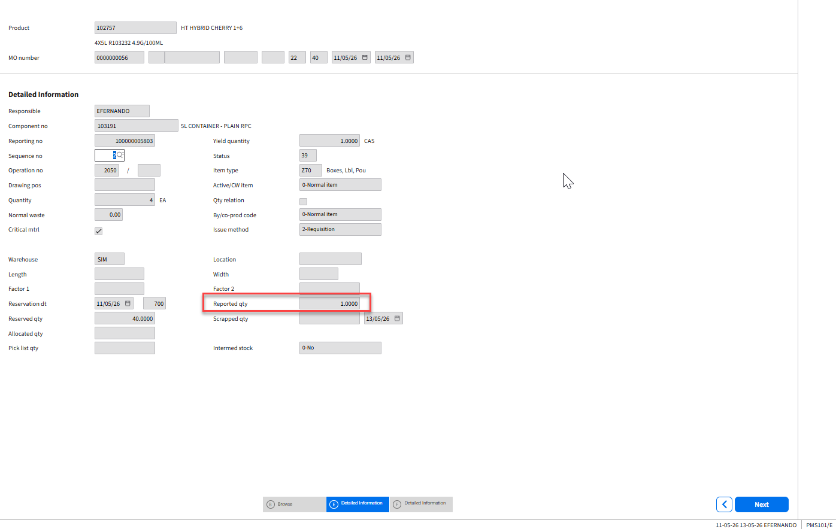
Figure 1: Reported quantity updated against a component line which triggers the workflow for operation start

Below is the sequence in which APIs are executed.

Step 01: Retrieve the Manufacturing Order number (VHMFNO), product number (VHPRNO), operation number (VMOPNO)
Manufacturing order number (VHMFNO), product number (VHPRNO), operation number (VMOPNO) to be retrieved from PMS101/E based on the component which has reported quantity updated.

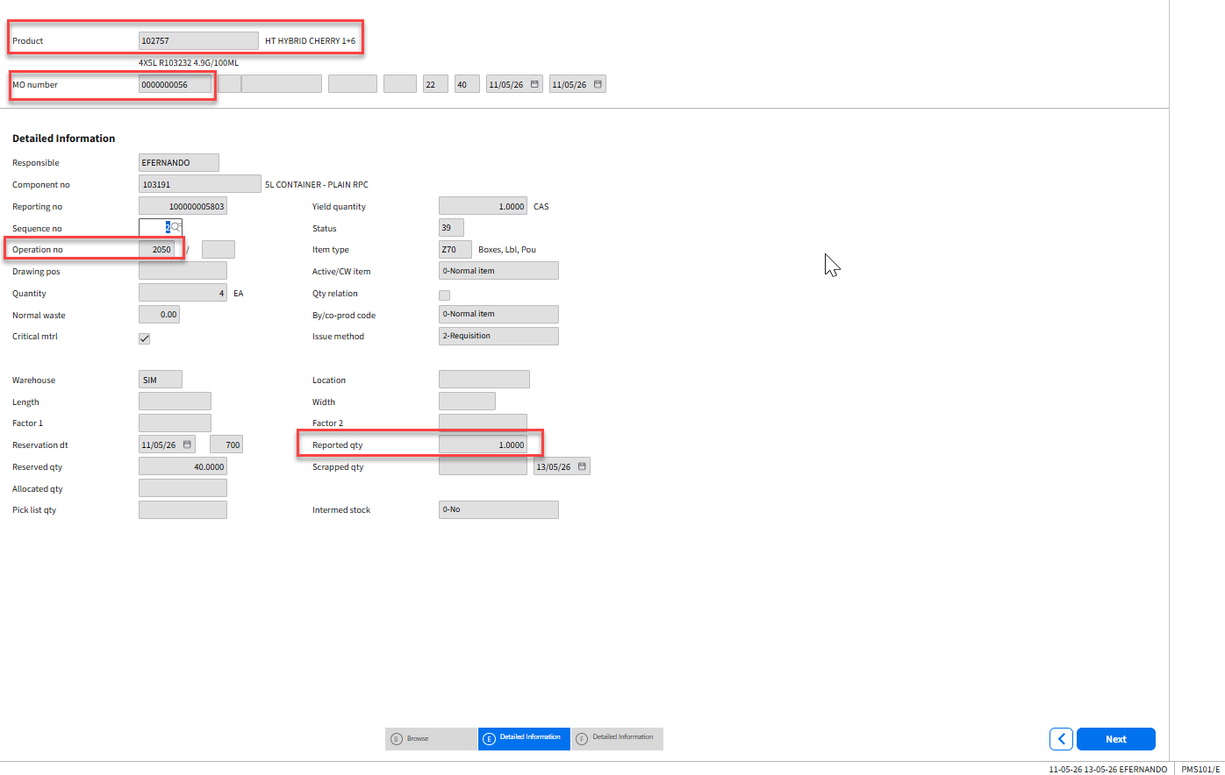
Figure 2: Capturing MO number, Product number, and operation number.

Step 02: Retrieving the work center and the reporting number connected to the operation
  - API: PMS100MI
  - Transaction: GetOperation
Description | Field | Test Value | Extraction Method
Facility | FACI | SB1 | Hardcoded
Product | PRNO | 153228 | VHPRNO retrieved in Step 01
Manufacturing Order Number | MFNO | 0000000056 | VHMFNO retrieved in Step 01
Operation Number | OPNO | 1010 | VMOPNO retrieved in Step 01
Table 1: Inputs to retrieve operation related information for the Manufacturing Order
Based on inputs to Table 1, below outputs are obtained.

Description | Field | Test Value
Reporting number | WOSQ | 100000004314
Work center | PLGR | MIX_A
Table 2: Retrieved work centre related information for the Manufacturing Order

Step 03: Retrieve the card number against the person logged in.

  - API: CRS530MI
  - Transaction: SelUserID
Description | Field | Test Value | Extraction Method
Division | DIVI | 100 | Hardcoded
User | USID | EFERNANDO | Use the MNS150 User ID of the logged in user
Table 3: Retrieve MNS150 user ID against the user
Based on inputs to Table 3, below outputs are obtained.

Description | Field | Test Value
Card Number | CANO | 2
Table 4: Card number retrieved for the user ID against the user

Step 04: Perform work start on the operation.
  - API: PMS420MI
  - Transaction: StartWorkOp
Description | Field | Test Value | Extraction Method
Card number | CANO | 2 | CANO from Table 4
Reporting number | WOSQ | 100000004314 | WOSQ from Table 2
Table 5: Perform work start on the operation

Automating operation stop
Once manufacturing quantity field is updated (Field: VHMAQA in MWOHED table), given manual completion flag is set to 1 (Field: VHREND in MWOHED table), given order status (Field VHWHST in MWOHED table) is status 80 and material status (Field: VHWMST in MWOHED table) is 99, operation stop needs to be executed.

Trigger to initiate the workflow.
Once manufacturing quantity field is updated (Field: VHMAQA in MWOHED table), given manual completion flag is set to 1 (Field: VHREND in MWOHED table), given order status (Field VHWHST in MWOHED table) is status 80 and material status (Field: VHWMST in MWOHED table) is 99, operation stop needs to be executed.
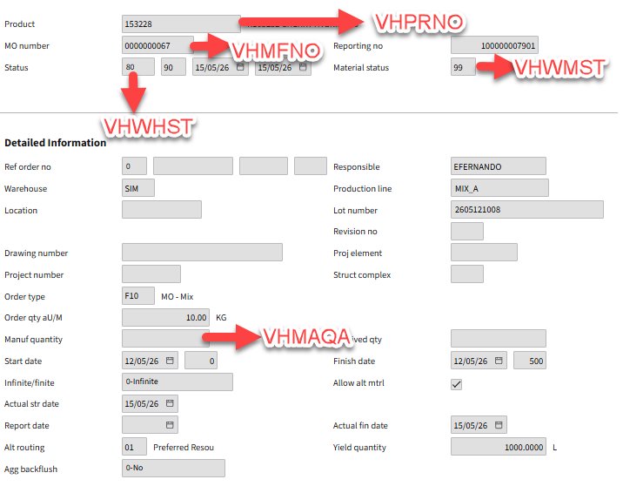
Figure 3: Manufactured quantity updated and manual completion flag set to 1 against the manufacturing order, given order status is 80 and material status is 99 triggers the workflow for operation stop

Below is the sequence in which APIs are executed.

Step 05: Retrieve the product number and the manufacturing order number
Once manufacturing quantity field is updated (Field: VHMAQA in MWOHED table), given manual completion flag is set to 1 (Field: VHREND in MWOHED table), given order status (Field VHWHST in MWOHED table) is status 80 and material status (Field: VHWMST in MWOHED table) is 99 in PMS100/E, product number (VHPRNO in MWOHED table) and manufacturing order number (VHMFNO in MWOHED table) should be captured.

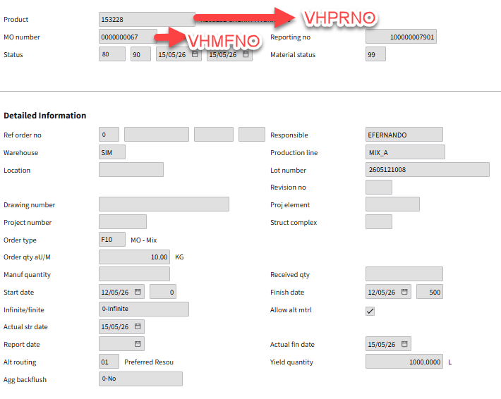
Figure 4: Capturing Manufacturing Order Number and Product Number

Step 06: Retrieve the non-labour work center on the manufacturing order
  - API: PMS100MI
  - Transaction: LstOperations
Description | Field | Test Value | Extraction Method
Facility | FACI | SB1 | Hardcoded
Product | PRNO | 153228 | VHPRNO captured in Step 05
Manufacturing Order Number | MFNO | 0000000056 | VHMFNO captured in Step 05
Table 6: Inputs to retrieve operations relevant for the Manufacturing Order
Based on inputs to Table 6, below outputs are obtained.

Description | Field | Test Value
Operation number | OPNO | 1009
Work center | PLGR | MIX_A
Table 7: Retrieve work centre related information for the Manufacturing Order

Step 07: If two records are retrieved in Table 7, select the record with the work center name not consisting of ‘LB’

Step 08: Retrieving the reporting number connected to the non-labour operation (Work center not consisting of LB)
  - API: PMS100MI
  - Transaction: GetOperation
Description | Field | Test Value | Extraction Method
Facility | FACI | SB1 | Hardcoded
Product | PRNO | 153228 | VHPRNO retrieved in Step 05
Manufacturing Order Number | MFNO | 0000000056 | VHMFNO retrieved in Step 05
Operation Number | OPNO | 1010 | OPNO in Step 06 for the non-labour operation (Work center not consisting of LB) identified in Step 07.
Table 8: Inputs to retrieve operation related information for the non-labour work center in the Manufacturing Order
Based on inputs to Table 8, below outputs are obtained.

Description | Field | Test Value
Reporting number | WOSQ | 100000004314
Work center | PLGR | MIX_A
Table 9: Work centre related information retrieved for the non-labour work center in the Manufacturing Order

Step 09: Retrieve the card number against the person logged in.
  - API: CRS530MI
  - Transaction: SelUserID
Description | Field | Test Value | Extraction Method
Division | DIVI | 100 | Hardcoded
User | USID | EFERNANDO | Use the MNS150 User ID of the logged in user
Table 10: Retrieve MNS150 user ID against the user
Based on inputs to Table 10, below outputs are obtained.

Description | Field | Test Value
Card Number | CANO | 2
Table 11: Card number retrieved for the user ID against the user

Step 10: Perform work stop on the operation.
  - API: PMS420MI
  - Transaction: StartWorkOp
Description | Field | Test Value | Extraction Method
Card number | CANO | 2 | CANO from Table 11
Reporting number | WOSQ | 100000004314 | WOSQ from Table 9
Manufactured quantity | MAQA | 1000 | Received quantity (Field: VHRVQA in MWOHED table) in PMS100/E
Table 12: Perform work stop on the operation

Assumptions & Limitations
- Only one active non-labour operation exists against the Manufacturing Order.
- The same user ID is assumed for both component issue transactions and final MO output reporting. The card number for that user is used to record operation start and stop.
- Operation start/ stop times will be unreliable on Manufacturing Orders on which reversals have happened.
- Closing a Manufacturing Order raised by error should only be done by right clicking the order in PMS100/B -> Related -> Close and should not be manually flag completed.

